
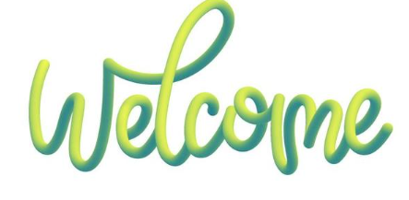

Dear New Resident,
On behalf of the Planning Board, we extend a warm welcome to you as you embark on this new chapter in our community. Whether you’ve recently moved here or are considering making our neighborhood your home, we’re delighted to connect with you.
The Planning Board is dedicated to enriching the lives of Passadumkeag’s residents and fostering a sense of belonging for all. From organizing local events to providing support services, we strive to create a vibrant and inclusive community where everyone feels valued and supported.
As you settle into your new surroundings, we invite you to explore all that our community has to offer. Whether it’s joining us for a neighborhood cleanup, attending one of our cultural festivals, or simply stopping by our office for a chat, we’d love to get to know you better.
Please don’t hesitate to reach out if you have any questions or if there’s anything we can assist you with. Welcome to the neighborhood, we’re thrilled to have you here!

Warm regards,
Sergio Batista

Sergio Batista
Passadumkeag Planning Board
passadumkeagplanboard@outlook.com
www.passadumkeagme.org

